Eleven Prophetic Clues Concerning
Joseph – Anglo-Saxon Nations

There is not much direct history connecting the tribes of Ephraim and Manasseh to the Anglo-Saxon peoples. We are talking about the two most important tribes of the lost tribes. Even the Caucasian population of the Anglo-Saxon nations comes from various backgrounds. So how can there be a tribe of Joseph? One can compare this to Jewry. The Jewish people have known many proselytes, yet, there has been a core of the tribe of Judah (and some of Levi & Benjamin) over the past 2500 years. The core passes on characteristics and genes to the periphery. Looking at the ‘prophetic clues’ one has to conclude, that a core of the tribe of Joseph (Ephraim and Manasseh) once found its way to the British Isles. This core passed its characteristics and genes on to the influx of others. The British spread out to America and the Commonwealth countries over the past 400 years. Below I will deal with prophetic clues between Joseph and the Anglo-Saxon peoples. The more fulfilled prophetic clues we find, the stronger our case. What follows is not historic proof, but proof by revelation.

1st Clue: Great Nation & Company of Nations

Now the sons of Reuben the firstborn of Israel, (for he was the firstborn; but, forasmuch as he defiled his father’s bed, HIS BIRTHRIGHT WAS GIVEN UNTO THE SONS OF JOSEPH the son of Israel: and the genealogy is not to be reckoned after the birthright. For Judah prevailed above his brethren, and of him came the chief ruler; BUT THE BIRTHRIGHT WAS JOSEPH’S (1Chron 5:1-2). (AV throughout unless stated otherwise).
And God said unto [Jacob], I am God Almighty: be fruitful and multiply; A NATION [GOY] AND A COMPANY OF NATIONS [KEHAL GOYIM] shall be of thee, and kings shall come out of thy loins (Genesis 35:11).
And his father [Jacob] refused, and said, I know it, my son, I know it: HE [MANASSEH] ALSO SHALL BECOME A PEOPLE, AND HE ALSO SHALL BE GREAT: but truly his younger brother [Ephraim] shall be greater than he, and his seed shall become A MULTITUDE OF NATIONS [GOYIM] (Genesis 48:19).

Jacob inherited the blessing, the birthright and the promise of the Messiah. Jacob even received a new promise that his descendants would become a great nation and a company of nations (Gen 35:11). The birthright did not go to Judah and the Jews. Judah got the promise of a prince, a king and of the Messiah. The birthright went to Joseph (1Chron 5:1-2). Judah never became a Company of Nations, not even a Great Nation. This promise would go to Joseph in the endtime. Joseph would get all the promises of national greatness that were promised to Abraham, Isaac an Jacob. The USA (Manasseh) and the Commonwealth (Ephraim) have become a Great Nation and a Company of Nations.
The Queen of England is also head of state of Canada, Australia, New Zealand and another 14 countries. Over the past two centuries the Anglo-Saxon nations have dominated world history. Those who ‘blessed’ them, were blessed themselves.

2nd Clue: Joseph … in the west …

And Pharaoh said unto Joseph, See, I have set thee over ALL THE LAND OF EGYPT (Gen 41:41).
And unto Joseph IN THE LAND OF EGYPT were born MANASSEH AND EPHRAIM, which Asenath the daughter of Potipherah priest of On bare unto him (Gen 46:20).
ON THE WEST SIDE shall be the standard of the camp of EPHRAIM according to their armies … And by him shall be the tribe of MANASSEH … Then the tribe of BENJAMIN … (Num 2:18-24).
And as for THE WESTERN BORDER, ye shall even have the great sea for a border: THIS SHALL BE YOUR WEST BORDER (Num 34:6).
I will not put into effect the heat of my wrath; I will not again send destruction on EPHRAIM; for I am God and not man, the Holy One among you; I will not put an end to you. They will go after the Lord; his cry will be like that of a lion; his cry will be loud, AND THE CHILDREN WILL COME FROM THE WEST, shaking with fear (Hosea 11:9-10).

Joseph and the tribes of Ephraim and Manasseh can often be found in the west. The 10 oldest brothers were born in Aram (Turkey/Syria). Benjamin is the only one to be born in Canaan. The 17-year-old Joseph was sold into Egypt and lived there for 93 years, until his death. From Canaan Egypt is towards the south, but especially towards the west. From Eilat Cairo is 270 miles due west.
Ephraim and Manasseh were born in Egypt and lived there their whole lives. In antiquity there were three major empires in the Middle-East, The Hittites in the north, the Assyrians / Babylonians in the east and the Egyptians in the (south)west.

The Tabernacle

There are three Rachel tribes: Ephraim, Manasseh and Benjamin. Those three Rachel-tribes were camped west of the tabernacle, under Ephraim’s leadership. I believe the western Vikings to be descendants of Benjamin. They ended up in Iceland, Denmark, Norway and the Faeroe Islands. Descendants of Ephraim and Manasseh settled on the British Isles, all three tribes in the west.
The western border of Canaan was the Great Sea (Mediterranean). Ephraim and Manasseh bordered the Great Sea (Yam Gadol) in the west. The other tribes (except for maybe Asher) were more or less cut off from the sea by the Philistines in the south and the Phoenicians in the north,
Of the lost tribes in Europe we see the utmost western position of Ephraim, Manasseh and Benjamin, compared to the other tribes.

Hosea

The book of Hosea is about the northern House of Israel, the House of Joseph, also called Ephraim. It is prophesied that ‘the children of Ephraim will come shaking from the west! (Hos 11:10).

English, to America

In the end the British spread to the four corners of the earth: His glory is like the firstling of his bullock, and his horns are like the horns of unicorns: with them he shall push the people together to the ends of the earth: and they are the ten thousands of Ephraim, and they are the thousands of Manasseh (Deuteronomy 33:17).
However, the British went west to begin with, to America and Canada. Through wars the New World colonies of the French, Dutch and Swedes were absorbed. In 1776 13 English colonies rebelled and declared their independence. From then on there were the United States and the British Empire.

Go West …

From the end of the 18th century people in America were trekking west. Pioneers and settlers moved further and further west. Where they ended up was called the frontier, the end of civilisation. The frontier moved constantly westwards. New lands were discovered. This is the time of the so-called ‘Wild West’. Many American films deal with this subject. Another link of Joseph (Manasseh) with ‘the West’.

The Dust Bowl

The decade of the thirties (’30-’39) was the Great Drought, the time of the Dust Bowl. It was also the time of the Great Depression. Many went west, especially to Oregon and California.

The West

The Anglo-Saxon culture is the culture of the West. The English and the Americans have defended freedom and freetrade. The English (19th C.) and the Americans (20th C.) kept the sealanes of the oceans open. Traditionally the English fleet had to be as big as the 2nd and 3rd fleet of the world. The fleets of Spain and France combined was not to be allowed to be bigger than the English fleet.
Since WW II the Americans have their fleet all over the world. Half the world’s aircraft carriers are American. Napoleon in 1815, the Central Powers in WW I, Hitler and Japan in WW II and the USSR during the cold War … all were stopped by ‘the West’, by the Anglo-Saxon Nations, by Ephraim and Manasseh, by the sons of Joseph.

3rd Clue: Joseph & Slavery

Then there passed by Midianites merchantmen; and they drew and lifted up Joseph out of the pit, and SOLD JOSEPH to the Ishmaelites for twenty pieces of silver: and they brought Joseph into Egypt (Gen 37:28).
And the Midianites SOLD [JOSEPH] into Egypt unto Potiphar, an officer of Pharaoh’s, and captain of the guard (Gen 37:36).
Wherefore shall we die before thine eyes, both we and our land? BUY US AND OUR LAND for bread, and we and our land WILL BE SERVANTS unto Pharaoh [Serfdom!] … And Joseph BOUGHT ALL THE LAND OF EGYPT for Pharaoh; for the Egyptians SOLD EVERY MAN HIS FIELD, because the famine prevailed over them: so the land became Pharaoh’s (Gen 47:19-20).
And Joseph said unto his brethren, Come near to me, I pray you. And they came near. And he said, I am Joseph your brother, WHOM YE SOLD INTO EGYPT (Gen 45:4).

Joseph & Slavery

Joseph was sold as a 17-year-old youngster to the Ishmaelites. He was sold for a second time to an Egyptian. Joseph was slave for 13 years, till the age of 30. He first worked in the house of Potiphar and later he was put at work in prison.
As vice-roy of Egypt he sold grain to the Egyptians. The moment they had no more money, he took their land for food. Thus he made the ordinary Egyptians – not the priests – a kind of serfs, a kind of slaves of Pharao. Joseph had a lot to do with slavery. Eventually Ephraim and Manasseh became slaves, just like the other tribes.

England & Slavery

A black page in the history of the west is the slavetrade. The Dutch, Danes, Portuguese, Spaniards, French, Americans and English bought slaves in ‘black’ Africa and sold them in the new world. The Americans and British were the main players. They brought 3½ million slaves to the new World (source: Wikipedia)

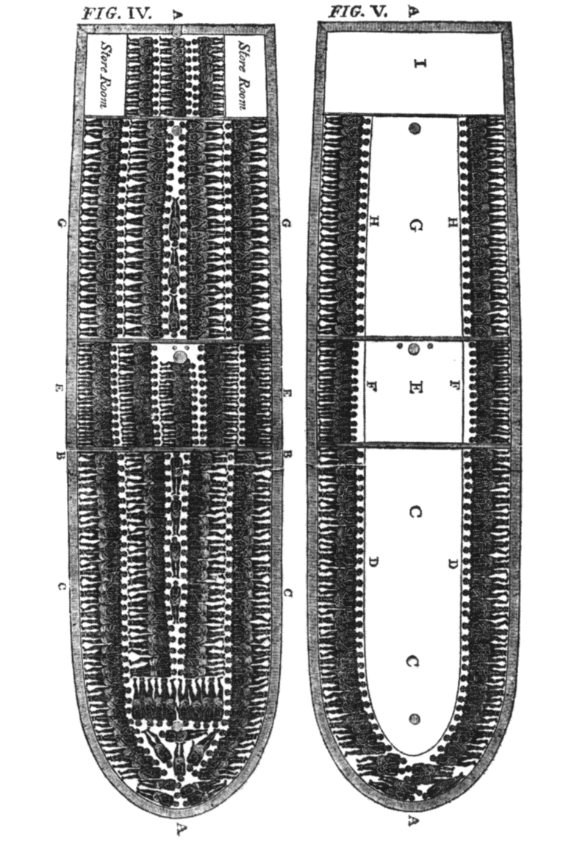
Slaveship

Abolitionism

England (Ephraim) also had an important role in abolishing the slave-trade, Wikipedia:
In 1783, an anti-slavery movement began among the British population. That year a group of Quakers founded the first British abolitionist organization. The Quakers continued to be influential throughout the lifetime of the movement, in many ways leading the campaign. … After the formation of the ‘Committee for the Abolition of the Slave Trade’ in 1787, William Wilberforce led the cause of abolition through the parliamentary campaign. It finally abolished the slave trade in the British Empire with the Slave Trade Act 1807. He continued to campaign for the abolition of slavery in the British Empire, which he lived to see in the Slavery Abolition Act 1833.

Uncle Tom’s Cabin

In the southern states of the USA slavery had created painful situations. Cotton and tobacco plantations ‘needed’ slavery. Uncle Tom’s Cabin by Harriet Beecher Stowe is one of the most famous novels in American literature and it is a world famous anti-slavery document. The book was published in 1852 and had a huge impact. Slavery was abolished in the US, January 1, 1863.

American Civil War

The extension of slavery was an important factor leading to the American Civil War (1861-1865). A war leaving more than 600,000 people dead. That is as many, or more, casualties than all the other American wars in total!
Wikipedia: The American Civil War was fought in the United States from 1861 to 1865. As a result of the long-standing controversy over slavery, war broke out in April 1861, when Confederate forces attacked Fort Sumter in South Carolina, shortly after U.S. President Abraham Lincoln was inaugurated. The nationalists of the Union proclaimed loyalty to the U.S. Constitution. They faced secessionists of the Confederate States, who advocated for states' rights to expand slavery.
Once free, the black people of America had no equal rights, hence the Civil Rights Movement of the fifties and sixties.
Ephraim (GB) and Manasseh (US) have had much to do with slavery.

4th Clue: Joseph & Prison

And Joseph’s master took him, and put him INTO THE PRISON, a place where the king’s prisoners were bound: and he was there IN THE PRISON (Gen 39:20).
And the keeper of the PRISON committed to Joseph’s hand ALL THE PRISONERS THAT WERE IN THE PRISON; and whatsoever they did there, he was the doer of it (Gen 39:22).
And he put them [the butler and the baker] IN WARD in the house of the captain of the guard, INTO THE PRISON, THE PLACE WHERE JOSEPH WAS BOUND (Gen 40:3).
If ye be true men, let one of your brethren [Simeon] be BOUND IN THE HOUSE OF YOUR PRISON: go ye, carry corn for the famine of your houses (Gen 42:19).
And he turned himself about from them, and wept; and returned to them again, and communed with them, and took from them SIMEON, AND BOUND HIM BEFORE THEIR EYES (Genesis 42:24).

Joseph & prison

Joseph was a slave for 13 years (age 17 till 30). For how long was he in Potiphar’s house? We do not know. However it is likely that he was longer in prison than in Potiphar’s house.
The first mention of a Hebrew word in scripture is meaningful. Prison is mentioned for the first time in Joseph’s story and is mentioned 12 times (Gen 39-42).
Joseph was put into prison and in prison he became a kind of chief-warden. As vice-roy of Egypt he threatened to emprison his brothers and ended up putting Simeon into prison, when the other nine went for Benjamin.

Australia

The English turned Australia into ‘a jail’:
Wikipedia: Between 1788 and 1868, about 162,000 convicts were transported by the British government to various penal colonies in Australia. The British government began transporting convicts overseas to American colonies in the early 17th century. When transportation ended with the start of the American Revolution, an alternative site was needed to relieve further overcrowding of British prisons and hulks. Earlier in 1770, James Cook charted and claimed possession of the east coast of Australia for Britain. … Britain chose Australia as the site of a penal colony, and in 1787, the First Fleet of eleven convict ships set sail for Botany Bay, arriving on 20 January 1788 to found Sydney, New South Wales, the first European settlement on the continent. Other penal colonies were later established in Van Diemen's Land (Tasmania) in 1803 and Queensland in 1824, while Western Australia, founded in 1829 as a free colony, received convicts from 1850. ... The last convict ship arrived in Western Australia on 10 January 1868.

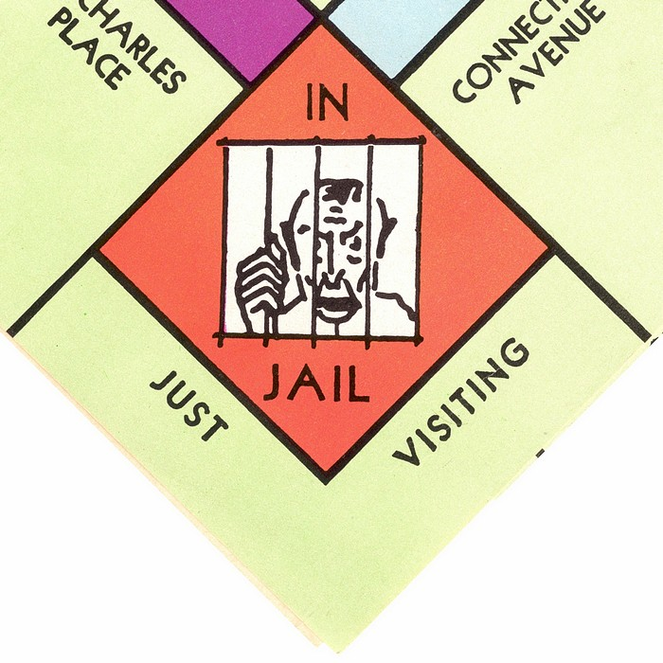
Monopoly: In Jail

USA

Compared to other nations America has a huge prison population. As capital punishment is still in force, many are on death row. As pharao’s chief baker was to be hanged, he was on death row too.
Wikipedia: In October 2013, the incarceration rate of the United States of America was the highest in the world, at 716 per 100,000 of the national population. While the United States represents about 4.4 percent of the world's population, it houses around 22 percent of the world's prisoners. Corrections (which includes prisons, jails, probation, and parole) cost around $74 billion in 2007 according to the U.S. Bureau of Justice Statistics. In 2016, the Prison Policy Initiative estimated that in the United States, about 2,298,300 people were incarcerated out of a population of 323.1 million. This means that 0.71% of the population was behind bars.

English Concentration Camps

The English are the inventors of concentration camps (not extermination camps), during the Boer wars (1899-1902). A concentration camp (or internment camp) is a place where a government forces people to live without trial.
Because of bad hygiene and neglect 27,927 women and children of the Boers (22,074 under the age of 16) died of starvation, illnesses and exhaustion. At the same time around 20,000 indigenous Africans died in the camps.
5th Clue: Joseph & Dreams

And [Joseph] said unto them, Hear, I pray you, this DREAM which I have DREAMED. For, behold, we were binding sheaves in the field, and, lo, my sheaf arose, and also stood upright; and, behold, your sheaves stood round about, and made obeisance to my sheaf (Gen 37:6-7).
And [Joseph] DREAMED yet another DREAM, and told it his brethren, and said, Behold, I have DREAMED a DREAM more; and, behold, the sun and the moon and the eleven stars made obeisance to me (Gen 37:9).
And the chief butler told his DREAM to Joseph, and said to him, In my DREAM, behold, a vine was before me (Gen 40:9).
When the chief baker saw that the interpretation was good, he said unto Joseph, I also was in my DREAM, and, behold, I had three white baskets on my head (Gen 40:16).
25 And Joseph said unto Pharaoh, The DREAM of Pharaoh is one: God hath shewed Pharaoh what he is about to do. 26 The seven good kine are seven years; and the seven good ears are seven years: the DREAM is one. 27 And the seven thin and ill favoured kine that came up after them are seven years; and the seven empty ears blasted with the east wind shall be seven years of famine (Gen 41:25-27).

Joseph & Dreams

Dreams were very dominant in Joseph’s life. There were his own dreams about the sheaves and about the sun, moon & stars. They were prophetic in that his own brothers would bow down before him. Then there were the dreams of the chief butler and the chief baker and in the end there were pharao’s dreams about the 7 good years and the 7 bad years.

Dreams: Films

Dreams are a kind of films in your head during the night, during sleep. The weirdest things, fantasies, happen in your dreams. That’s what it has in common with movies. One can put the craziest things into a film. For a long time the Anglo-Saxon nations have been leading in the field of film and televison. Other nations would buy English and American films and televison programmes, synchronise them into their own language, or subtitle them. The English speaking world is still leader in film and television. BBC and Hollywood are international notions. Their films are shown all over the world, and ‘foreign films’ are only shown in their own linguistic niche. Ephraim and Manasseh are quite dominant in the field of ‘dreams’.

Internet, Netflix, Youtube

Again and again innovations in the field of ‘dreams’ come from the English speaking world, like: Internet, Netflix, Facebook, Youtube, bloggers and vloggers.
All passed on by Manasseh (US) and Ephraim (UK).
Again and again the English-speaking world was copied: At first huge cinema’s were built. Then television was invented. First one channel, then two national channels. Advertisements and commercial televison were introduced, then cable and satelite tv. Special channels like National Geographic, Animal Planet, etc., TV through internet, netflix. Youngsters hardly watch television nowadays, as they are on their smartphones watching youtube and vloggers. Whatever: It all came and comes from Joseph.



The Academy Awards (Oscars) for best film, best actor, best director, etc. are an annual event. In Britain there are the BAFTA awards (BAFTA: British Academy of Film and Television Arts).

American Dream

Dream and dreams have become synonymous with plans, fantasies and desires. The USA is seen as the best place for realising one’s dreams. The American Dream has become an internationally known concept. America is the place where you can climb from nothing to something. From paperboy to millionaire. This too can first be seen in the Bible with Joseph. He rose from slave, prisoner, to chief prison warden to vice-roy in Egypt! He realised ‘his dreams’ and saved ‘the world’ from starvation!

I have a dream …

World famous is Dr. Martin Luther King’s speech: I have a dream … This too happened in the land of Manasseh.
At this moment of writing there is the political problem in the States of DACA, of ‘the dreamers’. It concerns the children of illegal immigrants who are ‘dreaming’ to be allowed to stay in the USA.

6th Clue: Joseph & Corn

And let them gather all the food of those good years that come, and lay up CORN … and let them keep food in the cities. … And Joseph gathered CORN as the sand of the sea, very much, until he left numbering; for it was without number (Gen 41:35, 49).
And the famine was over all the face of the earth: And Joseph opened all the storehouses, and sold unto the Egyptians … And all countries came into Egypt to Joseph for to buy CORN; because that the famine was so sore in all lands (Genesis 41:56-57).
… Jacob saw that there was CORN in Egypt, Jacob said … Behold, I have heard that there is CORN in Egypt: get you down thither, and buy for us … And Joseph’s ten brethren went down to buy CORN in Egypt (Gen 42:1-3).
[Isaac]: Therefore God give thee [Jacob] of the dew of heaven, and THE FATNESS OF THE EARTH, AND PLENTY OF CORN AND WINE: Let people serve thee, and nations bow down to thee: be lord over thy brethren … cursed be every one that curseth thee, and blessed be he that blesseth thee (Gen 27:28-29).
And of Joseph [Moses] said, Blessed of the LORD be his land, for the precious things of heaven, for the dew … And for the precious fruits brought forth by the sun … AND FOR THE PRECIOUS THINGS OF THE EARTH AND FULNESS THEREOF … let the blessing come upon the head of Joseph … and upon the top of the head of him that was separated from his brethren (Deut 33:13-16).

Egypt: Granary of Antiquity

https://www.ancient.eu/Roman_Egypt/ Octavian’s victory over Antony and Cleopatra awarded Rome with the richest kingdom along the Mediterranean Sea. His future was guaranteed. The country’s overflowing granaries were now the property of Rome; it became the 'breadbasket' of the empire, the 'jewel of the empire’s crown.'
However, at the time of Joseph too, Egypt was the granary of the world.

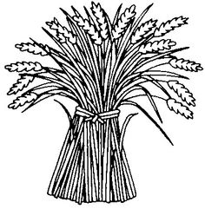

USA & Commonwealth:

Manasseh and Ephraim are big producers of wheat:

USA 55.4 million tonnes
Canada 29.3
Australië 25.3
UK 16.6
Total Joseph: 126.6 million tonnes of wheat of a production of 729 million tonnes worldwide (in 2014).

The Joseph countries export a lot more wheat than the other countries. Their combined exports are nearly 40% of the total world wheat export in 2016.

1. United States: 14.8%
2. Canada: 12.4%
4. Australië: 9.9%
14. UK: 1.4%
Total Joseph-countries 38.5%

Total Food Export

However, prophecies for the Joseph peoples are not just about wheat, but about food in general. The Joseph-countries also exported 26.8% of the world barley export of 2016.
Corn is mentioned 19 times in the Joseph story of the Bible. ‘Ochel’ or ‘food’ is mentioned another 14 times in the same story. The best parts of the earth were promised to Joseph (Gen 49:22-26; Deut 33:13-17). This promise did not go to Judah, to the Jews, but to Joseph! Joseph received the blessing and the birthright promise. Judah received promises concerning kingship and the messiah.
The Joseph countries still feed the world. World food export in 2016 was:

1. USA $ 150 billion
8. Canada $ 50
14. UK $ 32
15. Australië $ 31
20. N. Zeeland $ 24

Manasseh (USA) exported for $ 150 billion of food and Ephraim (Can-UK-AUS-NZ) for $ 137 billion.

7th Clue: brothers went to Joseph

And Judah and HIS BRETHREN CAME TO JOSEPH’S HOUSE; for he was yet there: and they fell before him on the ground (Gen 44:14).
And Joseph said unto his brethren, and unto his father’s house, I will go up, and shew Pharaoh, and say unto him, MY BRETHREN, and my father’s house, which were in the land of Canaan, ARE COME UNTO ME (Gen 46:31).
And Joseph placed his father and HIS BRETHREN, AND GAVE THEM A POSSESSION IN THE LAND OF EGYPT, in the best of the land, in the land of Rameses, as Pharaoh had commanded. And Joseph NOURISHED HIS FATHER, AND HIS BRETHREN, AND ALL HIS FATHER’S HOUSEHOLD, WITH BREAD, according to their families (Gen 47:11-12).

The brothers went to Joseph

Joseph was in Egypt and remained in Egypt. Joseph ‘stayed in the west’. His sons Ephraim and Manasseh were born there and always stayed there. Their 11 uncles came to them.
The first time only 10 of the brothers came, Benjamin did not come. The next time the brothers came with Benjamin. The third time the brothers came with their father, their wives and children and all their livestock.

Lands of immigration

The English speaking nations have been countries of immigration. The first immigrants were mainly from the other tribes. This also happened to England. Many Vikings (Benjamin) settled in North-England and the Danelaw; the Dutch (Zebulun) settled around the Wash and the Normans were of Danish (Benjamite) and French (Reuben) stock.
America received many immigrants from Scandivania (Benjamin & Naphtali), the Benelux (Issachar, Zebulun and Asher), France (Reuben) and Ireland (Dan). Many British (Ephraim, Manasseh, Simeon) came to the States too.

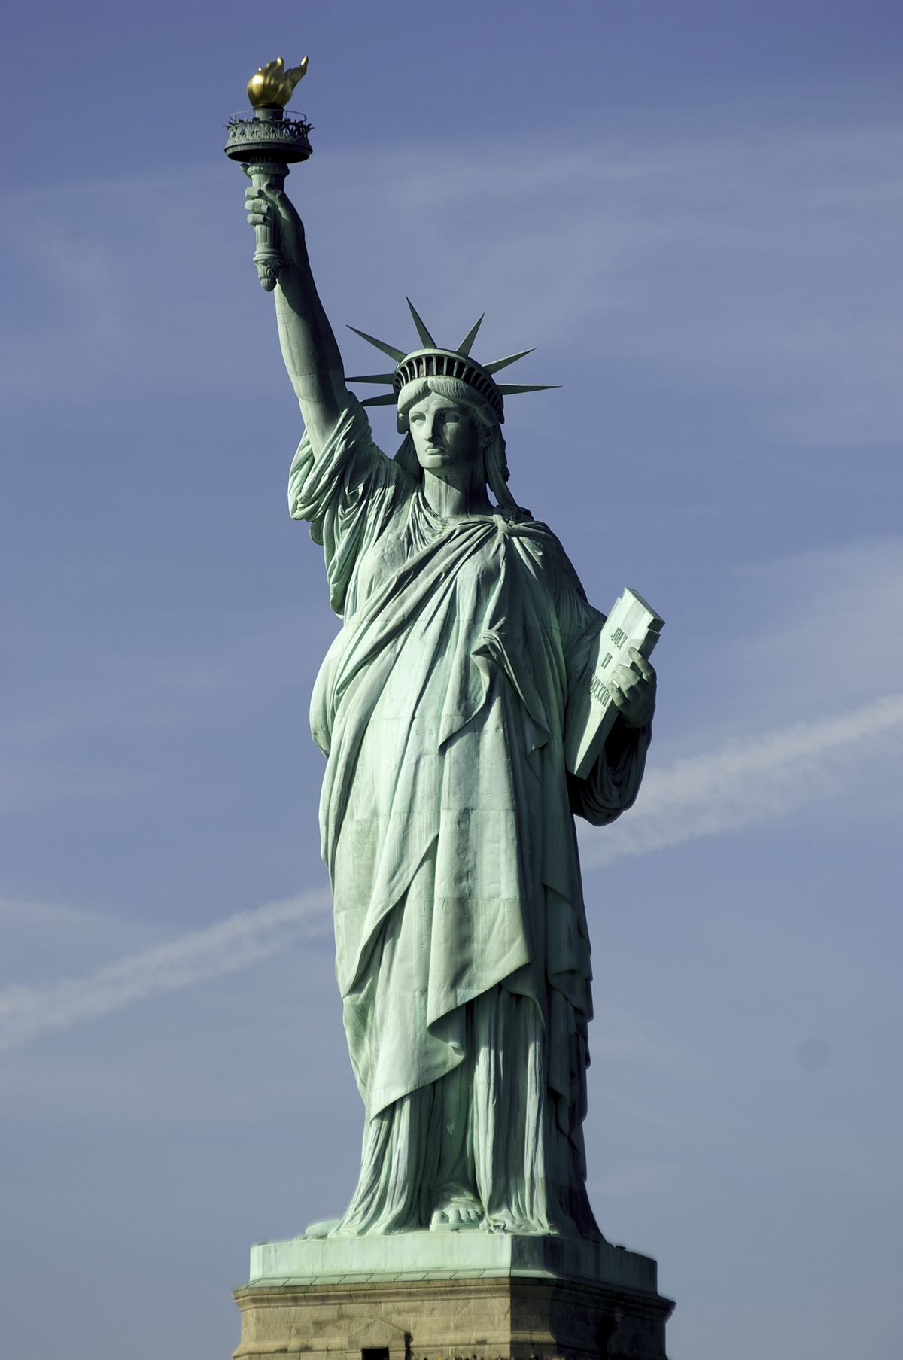

Background by country

In the States questions have been asked at polls about national background. Some have admitted more than one background:

36 million Irish background
27 million English
9 million French
6 million Scottish
5 million Scottish-Irish
5 million Dutch
5 million Norwegian
4 million Swedish
2 million French-Canadian
2 million Welsh
1½ million Danish

Many people from Scandinavia, the Benelux and France have joined Joseph in the United States. This fits in with the two sticks of wood in Ezekiel 37. Some Israelites are with Juda (Jewry), but ‘all’ of Israel is with Joseph (US & UK), with Ephraim:
The word of the LORD came again unto me, saying, Moreover, thou son of man, take thee one stick, and write upon it, FOR JUDAH, AND FOR THE CHILDREN OF ISRAEL HIS COMPANIONS: then take another stick, and write upon it, FOR JOSEPH, THE STICK OF EPHRAIM, AND FOR ALL THE HOUSE OF ISRAEL HIS COMPANIONS: And join them one to another into one stick; and they shall become one in thine hand [still to be fulfilled] (Ezekiel 37:15-17).

Can-Aus-NZ-RSA

Canada, Australia, New Zealand and RSA are English Ephraim-countries which also absorbed many immigrants from the other Israelite nations.
Like the brothers went to Joseph ‘in the west’, into Egypt, in Antiquity, thus emigrated many people of the other tribes to the Joseph-nations, to Ephraim (Commonwealth) and Manasseh (USA).

Other peoples too …

However, that was not all. The Joseph-countries have become a haven for many people from many nations: AND ALL COUNTRIES CAME INTO EGYPT TO JOSEPH for to buy corn; because that the famine was so sore in all lands (Gen 41:57).

8th Clue: Joseph & Corn: God’s Word

[Isaac to Jacob]: Therefore God give thee of the dew of heaven, and the fatness of the earth, and plenty of CORN and wine … cursed be every one that curseth thee, and blessed be he that blesseth thee (Gen 27:28-29).
Now the sons of Reuben the firstborn of Israel, (for he was the firstborn; but, forasmuch as he defiled his father’s bed, HIS BIRTHRIGHT WAS GIVEN UNTO THE SONS OF JOSEPH the son of Israel: and the genealogy is not to be reckoned after the birthright. For Judah prevailed above his brethren, and of him came the chief ruler; BUT THE BIRTHRIGHT WAS JOSEPH’S) (1Chronicles 5:1-2).
HE THAT WITHHOLDETH CORN, the people shall curse him: but blessing shall be upon the head of him that selleth it (Prov 11:26).
And all countries came into Egypt TO JOSEPH FOR TO BUY CORN; because that the famine was so sore in all lands (Gen 41:57).
The prophet that hath a dream, let him tell a dream; and he that hath MY WORD [=CORN], let him speak MY WORD faithfully. What is the CHAFF [=false prophecy] to the WHEAT? saith the LORD (Jer 23:28).
Behold, the days come, saith the Lord GOD, that I will send a FAMINE in the land, not a famine of BREAD, nor a thirst for water, BUT OF HEARING THE WORDS of the LORD (Amos 8:11).
But he answered and said, It is written, Man shall not live by BREAD alone, but by every WORD that proceedeth out of the mouth of God (Mt 4:4).
And it will come about that, as you were a curse among the nations, O children of Judah AND CHILDREN OF ISRAEL, so I will give you SALVATION and you will be a BLESSING: have no fear … (Zech 8:13).
Corn – Bread – God’s Word

There is a spiritual meaning to Joseph selling corn to ‘the whole world’. Everyone knows that Abraham’s seed was to become a blessing to all nations, and that it was fulfilled by Judah and Jesus. Most Bible books were written by Jews (=Israelites of Judah, Benjamin and Levi), by the House of Judah. The ultimate salvation is Yeshua, the Messiah from Judah. However, Judah has not spread God’s Word (=corn, =bread) over the earth. The Anglo-Saxon nations have been most active in mission, translating and distribution of the Bible. It is a spiritual fulfilment of ‘selling corn’ to the world.
The birthright and blessing went from Abraham to Isaac, from Isaac to Jacob, from Jacob to Joseph and from Joseph to Ephraim and Manasseh. From them came the Anglo-Saxon nations and they have been prolific in distributing Bibles and spreading the gospel, more than any other nation. Thus Joseph has been a ‘blessing to the nations’ over the past 250 years.

(John) Wycliffe

Wikipedia: Wycliffe Global Alliance is an alliance of organisations with the common objective of translating the Bible for every language group that needs it. Wycliffe was founded in 1942 by William Cameron Townsend. Before 1942, it was known as Camp Wycliffe, after which it became Wycliffe Bible Translators. The organization is named after John Wycliffe, who was responsible for the first complete English translation of the whole Bible into Middle English. … As of November 2012, translations of either portions of the Bible, the New Testament, or the whole Bible exist in over 2,800 of the 6,877 languages used on Earth.

William Carey – Father Missionry

Wikipedia: William Carey (17 August 1761 – 9 June 1834) was a British Christian missionary, Particular Baptist minister, translator, social reformer and cultural anthropologist who founded the Serampore College and the Serampore University, the first degree-awarding university in India. … Carey is known as the "father of modern missions." His essay, ‘An Enquiry into the Obligations of Christians to Use Means for the Conversion of the Heathens’, led to the founding of the Baptist Missionary Society. … He translated … the Bible into Bengali, Oriya, Assamese, Marathi, Hindi and Sanskrit. William Carey has been called a reformer and illustrious Christian missionary.

Bibles & the Name of Jesus

The United States still send out the most missionaries, 127,000 in 2010. Brazil, number 2 on the list, sent out 34,000 missionaries in 2010.
The English speaking nations have especially used radio, tv, internet, satelite tv, etc. to spread the gospel (corn). Thinking of God’s Word in connection with the English speaking world, the following comes to mind: J. Hudson Taylor, John Wycliffe, William Carey, TBN, GodChannel, BBC, Scofield, YWAM, OMF, John Bunyan, John Wesley, David Livingstone, Charles Spurgeon, Hillsong, George Fox, King James Bible, Companion Bible, NIV, Dr. Strong, Michael W. Smith, Billy Graham, praisemusic, OM, Songs of Praise, etc.
In this field Ephraim and Manasseh (USA & Commonwealth) have been a blessing to the nations over the past 250 years.

9th Clue: Joseph & Capitalism

14 AND JOSEPH GATHERED UP ALL THE MONEY that was found in the land of Egypt, and in the land of Canaan, for the corn which they bought: and Joseph brought the money into Pharaoh’s house. 15 AND WHEN MONEY FAILED IN THE LAND OF EGYPT, and in the land of Canaan, all the Egyptians came unto Joseph, and said, Give us bread: for why should we die in thy presence? for the money faileth. 16 AND JOSEPH SAID, GIVE YOUR CATTLE; AND I WILL GIVE YOU FOR YOUR CATTLE, IF MONEY FAIL. 17 And they brought their cattle unto Joseph: and Joseph gave them bread in exchange for horses, and for the flocks, and for the cattle of the herds, and for the asses: AND HE FED THEM WITH BREAD FOR ALL THEIR CATTLE FOR THAT YEAR. 18 When that year was ended, they came unto him the second year, and said unto him, We will not hide it from my lord, HOW THAT OUR MONEY IS SPENT; MY LORD ALSO HATH OUR HERDS OF CATTLE; there is not ought left in the sight of my lord, BUT OUR BODIES, AND OUR LANDS: 19 Wherefore shall we die before thine eyes, both we and our land? BUY US AND OUR LAND FOR BREAD, AND WE AND OUR LAND WILL BE SERVANTS UNTO PHARAOH: and give us seed, that we may live, and not die, that the land be not desolate. 20 AND JOSEPH BOUGHT ALL THE LAND OF EGYPT FOR PHARAOH; FOR THE EGYPTIANS SOLD EVERY MAN HIS FIELD, because the famine prevailed over them: so the land became Pharaoh’s. 21 AND AS FOR THE PEOPLE, HE REMOVED THEM TO CITIES from one end of the borders of Egypt even to the other end thereof (Gen 47:14-21).

Industrialisation & Capitalism

Britain and America have been the main promotors of capitalism over the past 250 years.
Wikipedia: In the mid-18th century, a new group of economic theorists, led by David Hume and Adam Smith, challenged fundamental mercantilist doctrines such as the belief that the world's wealth remained constant and that a state could only increase its wealth at the expense of another state.
During the Industrial Revolution, industrialists replaced merchants as a dominant factor in the capitalist system and affected the decline of the traditional handicraft skills of artisans, guilds and journeymen. Also during this period, the surplus generated by the rise of commercial agriculture encouraged increased mechanization of agriculture. Industrial capitalism marked the development of the factory system of manufacturing, characterized by a complex division of labor between and within work process and the routine of work tasks; and finally established the global domination of the capitalist mode of production. Britain also abandoned its protectionist policy as embraced by mercantilism …
After the First and Second Opium Wars and the completion of British conquest of India, vast populations of these regions became ready consumers of European exports. Also in this period, areas of sub-Saharan Africa and the Pacific islands were incorporated into the world system. Meanwhile, the conquest of new parts of the globe, notably sub-Saharan Africa, by Europeans yielded valuable natural resources such as rubber, diamonds and coal and helped fuel trade and investment between the European imperial powers, their colonies and the United States.
Reaganomics (USA, Manasseh) and Thatcherism (UK, Ephraim) have enriched the rich, and impoverished the poor since the 1980’s.

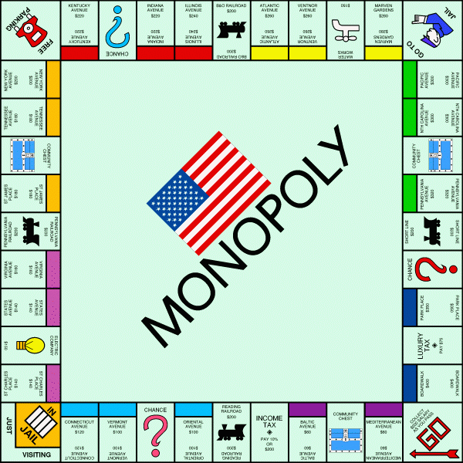

Joseph & Monopoly

In Genesis 47 Joseph played, as it were, Monopoly with the Egyptians. They gave all their money for food; then they sold all their cattle for food and in the end they sold themselves for food to stay alive. In the end the Monopoly player owns everything. In the (Anglo-Saxon) capitalistic world the rift between the haves and have-nots increases all the time. 1% of the population of the world owns half the wealth of the world. The Top Ten list of the richest people in the world has seven Americans. Forbes' 2018 top 15 billionaires: 1. Jeff Bezos, $112 billion; 2. Bill Gates, $90 billion; 3. Warren Buffett, $84 billion, etc.

Buy on Credit

For ages it has been the American way to buy things on credit. This costs a lot of extra money and impoverishes people. In the States people often need to have two or three jobs to be able to make ends meet. Everyone is ‘free’ in principle, everyone can chase the American Dream, but it remains a fact that many in this rich country are poor. Many have no health insurance. People are ‘enslaved’ to buying on credit.
Wikipedia: Most Americans will spend at least one year below the poverty line at some point between ages 25 and 75. Poverty rates are persistently higher in rural and inner city parts of the country as compared to suburban areas. Estimates of the number of Americans living in poverty are nuanced. One organization estimated that in 2015, 13.5% (43.1 million) of Americans lived in poverty. Yet other scholars underscore the number of Americans living in "near-poverty," putting the number at around 100 million, equating to a third of the U.S. population. Starting in the 1930s, relative poverty rates have consistently exceeded those of other wealthy nation.

10th Clue: Joseph & the Cross

13 Then taking Ephraim with his right hand, Joseph put him at Israel’s left side, and with his left hand he put Manasseh at Israel’s right side, placing them near him. 14 And Israel, stretching out his right hand, put it on the head of Ephraim, the younger, and his left hand on the head of Manasseh, CROSSING HIS HANDS on purpose,

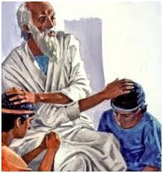

for Manasseh was the older. 15 And he gave Joseph a blessing, saying, May the God to whom my fathers, Abraham and Isaac, gave worship, the God who has taken care of me all my life till this day, 16 The angel who has been my saviour from all evil, send his blessing on these children: and let my name and the name of my fathers, Abraham and Isaac, be given to them; and let them become a great nation in the earth. 17 Now when Joseph saw that his father had put his right hand on the head of Ephraim, it did not seem right to him; and lifting his father’s hand he would have put it on the head of Manasseh. 18 And Joseph said to his father, Not so, my father, for this is the older; put your right hand on his head (Gen 48:13-18, BBE).

Jacob/Israel, 22nd generation

Jacob’s name was changed to Israel. Jacob/Israel is the 22nd generation since Adam (20. Abraham, 21. Isaac, 22. Jacob/Israel). Therefore 22 is the number of Israel, but it is also the number of the cross. The Hebrew Alphabet has 22 letters. The last and 22nd letter is the Tav, which had the form of a cross (1500 – 500 BCE) until the return from the Babylonian captivity. The current Hebrew script comes from Aramese, also called Assyrian letters.

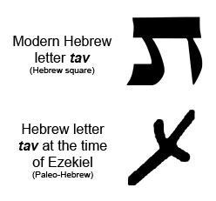

The 22nd letter, the Tav, was a cross. That’s why it is noteworthy that Jacob/Israel, who is the 22nd generation, passed on the birthright and blessing to Ephraim and Manasseh, with CROSSED arms. Their descendants would have nations with flags with crosses and Ephraim and Manasseh would spread the message of the cross over the globe. The cross also means suffering and Jacob and Joseph had not seen each other for 22 years!

http://www.crwflags.com/fotw/flags/


England – red on white



Scotland – white on blue

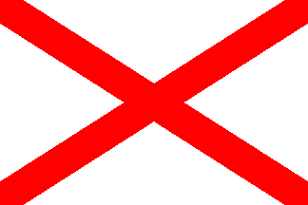

St. Patrick’s Flag – red on white


Early Union Jack – red and white crosses on blue


UK flag: flags of England, Scotland and (old) Irish flag


Australia


New Zealand

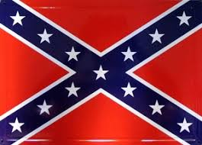
Confederate States of America

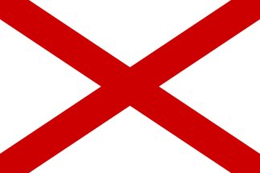
Alabama (US)

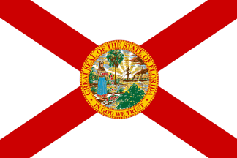
Florida (US)


Hawaii (US)

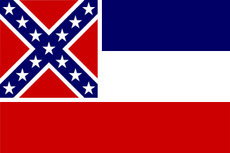
Mississippi (US)


Nieuw Mexico (US)


Taunton, Massachusetts (US)


Portland, Oregon (US)


Jackson, Mississippi (US)


Little Rock, Arkansas (US)


Anguilla (GB)
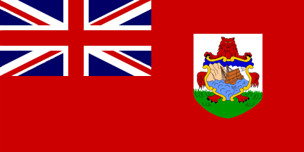
Bermuda (GB)

Falkland Islands (GB)
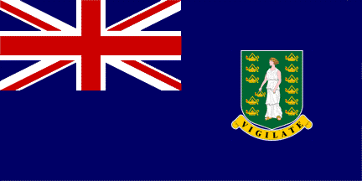
Virgin Islands (GB)

British Navy Ensign (GB) (red)

11th Clue: Joseph & Judah

And JUDAH SAID unto his brethren, What profit is it if we slay our brother, and conceal his blood? COME, AND LET US SELL HIM [Joseph] TO THE ISHMEELITES … (Gen 37:26-27).
Now though Joseph saw that these were his brothers, THEY HAD NO IDEA WHO HE WAS (Gen 42:8, BBE, Bible in Basic English).
AND JUDAH AND HIS BRETHREN CAME TO JOSEPH’S HOUSE … (Gen 44:14).
God sent me before you to keep you … living on earth … SO NOW IT WAS NOT YOU WHO SENT ME HERE, BUT GOD: … (Gen 45:7-8, BBE).
And he blessed Joseph, and said, God … BLESS THE LADS; AND LET MY NAME BE NAMED ON THEM … and let them grow into a multitude in the midst of the earth (Gen 48:15-16).
His [Joseph’s] glory is like the firstling of his bullock, and his horns are like the horns of unicorns: with them he shall push the people together TO THE ENDS OF THE EARTH: and they are the ten thousands of EPHRAIM, and they are the thousands of MANASSEH (Deut 33:17).
And there was war between Rehoboam [king of Judah] and Jeroboam [king of Joseph] all their days (1Kings 14:30).
And He shall … ASSEMBLE THE OUTCASTS OF ISRAEL [=JOSEPH], AND GATHER TOGETHER THE DISPERSED OF JUDAH FROM THE FOUR CORNERS OF THE EARTH. The envy also of Ephraim shall depart, and the adversaries of Judah shall be cut off: EPHRAIM SHALL NOT ENVY JUDAH, AND JUDAH SHALL NOT VEX EPHRAIM (Isa 11:12-13).

Jealousy and envy

There was and is brotherly jealousy between Judah and Joseph, at the time of the brothers, at the time of their descendants between the House of Judah (south) and the House of Joseph (north) and between their descendants now in modern times.
On the one hand there is hate and envy and on the other hand blood is thicker than water: reaching each other the helping hand. It was Judah’s idea to sell Joseph. Joseph tested Judah forcing him to fetch Benjamin and trying him to leave Benjamin, after the silver cup was found. Judah was a converted man and did not leave Benjamin.
Some reject the truth about the lost tribes in north-western Europa by saying: ‘If it were true, the Jews would know, wouldn’t they?’. To me that is a sign that it is true. Judah did not recognise Joseph in Egypt. Likewise most Jews do not recognise Joseph in this end-time.
The name of Israel went from Jacob to the sons of Joseph (Gen 48:14-16). That’s why the 10 northern tribes under the leadership of Ephraim and Manasseh are called (the house of) Israel, and the south is called (the house of) Judah. Judah under king David fought a civil war aginst Abner and his king, against Israel. At the time of Abner and David’s civil war Benjamin was part of the north.
Joseph had been sold by Judah for money. The Ten Tribes of the north (Israel/Joseph/Ephraim) rebelled and seceded over money, over taxes. Manasseh (USA) seceded from Ephraim (GB) over money, over taxes.
For two centuries the two kingdoms, the House of Judah (Jews) and the House of Israel (Israelites) existed side by side. Most of the time they were at war with one another. When the term ‘Jews’ (Yehudim) is used for the first time in the Bible … they are at war with Israel! (2Ki 16:5-6).
Yet, they are related. King Jehoshaphat (from Judah) once said to King Jehoram (from Joseph): And [Jehoshaphat] said, I will go up: I am as thou [Jehoram] art, my people as thy people, and my horses as thy horses (2Ki 3:7b).

Israel/Joseph disappeared

The man Joseph disappeared, out of sight. The Ten Tribes, the House of Joseph, disappeared too. They went into the Assyrian captivity.

To the ends of the earth …

The British spread out to the ends of the earth and eventually formed the USA and the (British) Commonwealth, as it was predicted by Moses (Deut 33:17). In the 19th century the British Empire (Ephraim) nearly covered a quarter of all the landsurface of the world and it contained a quarter of the world’s population.
Judah followed Joseph to the ends of the earth. Especially the pogroms in eastern Europe drove many Jews to the Anglo-Saxon nations. Most Jews (Judah) still live with Joseph! About 6.4 million Jews live in Medinat Yisrael; in the USA (Manasseh) there are also about 6.4 million Jews and yet another 850,000 in the other Ephraim countries. So there are still more Jews (Yehudim) with Joseph, than there are Jews in the Jewish State of Israel.
This makes Isaiah 11:12-13 comprehensible. After the Return the remnant of Joseph and the remnant of Judah shall come from the four corners of the earth (US, UK, Can, RSA, Aus, NZ)!.

Joseph & the Jewish State

Looking at the history of the Jewish State of Israel we see that it exists thanks to the Joseph peoples. The Balfour declaration of Ephraim in 1917; during the mandate of Ephraim the Jewish population went from 76,000 to 608,000. However, Ephraim did not want to estrange Ishmael (the Arabs) and they limited Jewish immigration. Some Jews (Judah) began a campaign of terror against Ephraim. In november 1947 the other Joseph nations – except England – voted in favour of a Jewish State (England abstained). The past 70 years the Jewish State has received special protection from the USA (Manasseh). The State of Israel has received $135 billion in support from the USA since WW II. In the Security Council of the UN the USA (Joseph) often vetoes, to protect the State of Israel (Judah).
B’nei Menashe & B’nei Ephraim

Wikipedia: B’nei Menashe: “The Bnei Menashe (Hebrew: בני מנשה‎, "Sons of Menasseh") are a ethnolinguistic group in India's North-Eastern border states of Manipur and Mizoram; since the late 20th century, they claim descent from one of the Lost Tribes of Israel and have adopted the practice of Judaism. The Bnei Menashe are made up of Hmar people (Mizo, Kuki, Zomi) and Chin peoples (Lai, Mara), who all speak Tibeto-Burman languages, and whose ancestors migrated into northeast India from Burma mostly in the 17th and 18th centuries … They are called Chin in Burma. In the late 20th century, Israeli Rabbi Eliyahu Avichail of the group Amishav named them Bnei Menashe, based on their account of descent from Menasseh [Manmasi in their tradition]. Most of the peoples in these two northeast states, who number more than 3.7 million, do not identify with these claims. Prior to conversion in the 19th century to Christianity by Welsh Baptist and Evangelical missionaries, the Chin, Kuki, and Mizo peoples were animists; among their practices was ritual headhunting. Since the late 20th century, some of these peoples have begun following Messianic Judaism. The Bnei Menashe are a small group who started studying and practicing Judaism since the 1970s in a desire to return to what they believe is the religion of their ancestors. The total population of Manipur and Mizoram is more than 3.7 million. The Bnei Menashe number around 10,000; close to 3,000 have emigrated to Israel.”

Internet: B’nei Ephraim:
https://shavei.org/bnei-ephraim/ “The Bnei Ephraim is a small community in rural India that claims to be the descendants of the biblical tribe of Ephraim, exiled from the land of Israel nearly 3,000 years ago. While their history is far from clear-cut, at least one member of this group has found his way to Israel, where he has lived for the last 17 years. See our profile of Yehoshua Yacobi here. Yacobi’s father Shmuel “founded” the Bnei Ephraim community. A former Christian preacher, Shmuel visited Israel in the early 1980s and became convinced that his – and his people’s – past was Jewish, not Christian. The Bnei Ephraim, Shmuel asserts, migrated from northern India, or perhaps via Afghanistan or the Mizoram and Manipur regions (where the Bnei Menashe settled after their own wanderings), settling ultimately in an area called Nandial. Upon his return from Israel to India, Shmuel was joined in his journey to Judaism by his siblings and their children – some 30 families in total … The Bnei Ephraim have had a remarkable if brief history and demonstrate a true passion for Judaism. While their roots remain unclear, Shavei Israel is assisting the community with fulfilling its heartfelt desire to deepen their knowledge of Jewish belief and practice.”

Let it be clear that the above Judaizing communities of B’nei Menashe and B’nei Ephraim do not fulfil the prophecies for Ephraim and Manasseh at all. They are not great nations. They did not spread out to the four corners of the earth. They are poor and not prosperous. They did not feed the world. They did not spread the Bible, spiritual corn, to the four corners of the world. They have not been protection for Judah, or the other tribes, etc.

Messianic Ephraim Teaching

There are also those who teach about the Two Houses, but differ from Anglo-Israelism. “The House of Ephraim (The Ten Tribes) got mixed with the nations and are now ‘goyim’, but if they start keeping sabbaths and God’s festivals they become one with the Messianic Jews. Then the two woods are together again within the Messianic Movement. The ‘goyim’ from Ephraim stock are grafted in on the Vine (Judah or Messianic Jews)”. I am doing my best to summarise this teaching, although their are variations. The theory poses a lot of unsolvable questions to my liking:

Are all 2.4 billion Christians of the world population the Lost Tribes? Or just the protestants? Or just the sabbatarians among the protestants? Jews are Jews, whether they are atheist or not. There is a physical descendance. Are atheist Dutch people Ephraim too, or do they become Ephraim the moment they become Christian, or Protestant, or Messianic?

In my view the theory does not hold. There are 13 tribes, if we include Levi. In the 7th Millennium the remnant of these tribes will come to live between the Euphrates and the Nile. The great coming exodus will be greater than the Exodus from Egypt (Jer 16:14-15), maybe 1 to 3 million per tribe. These are physical descendants of the 13 tribes. 7 tribes will live north of Jerusalem and Levi and 5 tribes will live south of Jerusalem and Levi (Ezekiel 47-48). THUS and THEN the two woods will be joined together! The rest of the world will consist of believers as well. All will keep Sabbath, New Moon and Tabernacles (Isa 66:23 & Zech 14). They will all know Yeshua, but they are not all Judah and Ephraim.

In this ‘Goyim-Ephraim-Two House teaching’ there is no place for the specific prophecies concerning Ephraim and Manasseh, let alone for Reuben and Zebulun. Above I have described 11 clues identifying the Anglo-Saxon nations as Joseph. There are many more clues. If you study the prophecies concerning
Ephraim and Manasseh in detail, you’ll end up with the English speaking nations sooner or later.
Bert Otten
June 2018
Gouda, Holland

